**Detection of Cyber Attack in Network using Machine Learning Techniques**

**ABSTRACT**

- Stood out from the past, enhancements in PC and correspondence advancements have given expansive and moved changes. The utilization of new developments give inconceivable benefits to individuals, associations, and governments, nevertheless, some against them. For example, the assurance of critical information, security of set aside data stages, availability of data, etc. Dependent upon these issues, advanced anxiety based abuse is perhaps the main issues nowadays. Computerized fear, which made a lot of issues individuals and foundations, has shown up at a level that could subvert open and country security by various social occasions, for instance, criminal affiliation, capable individuals and advanced activists. Thusly, Intrusion Detection Systems (IDS) has been made to keep an essential separation from advanced attacks. At this moment, learning the reinforce support vector machine (SVM) estimations were used to perceive port compass attempts reliant upon the new CICIDS2017 dataset with 97.80%, 69.79% accuracy rates were cultivated independently. Maybe than SVM we can present some different calculations like arbitrary woods, CNN, ANN where these calculations can obtain correctnesses like SVM – 93.29, CNN – 63.52, Random Forest – 99.93,ANN – 99.11*.*

**INTRODUCTION**

Lately, the world has seen a critical evolution in the various spaces of associated innovations like brilliant matrices, the Internet of vehicles, long haul advancement, and 5G correspondence. By 2022, it is normal that the quantity of IP-associated gadgets will be multiple times bigger than the worldwide populace, delivering 4.8 ZB of IP traffic yearly, as revealed by Cisco [1]. This sped up development raises overpowering security worries because of the trading of enormous measures of sensitive data through asset compelled gadgets and over the untrusted ''Internet'' utilizing heterogeneous advances and correspondence conventions. To keep up feasible and secure the internet, progressed security controls and flexibility investigation ought to be applied in the prior stages before sending.

The applied security controls are answerable for forestalling, identifying, and reacting to assaults. For location purposes an interruption recognition framework (IDS) is a generally utilized procedure for identifying interior and outer interruptions that objective a system, just as irregularities that show likely interruptions and dubious exercises. An IDS includes a bunch of instruments and mech anisms for observing the PC framework and the organization traffic, as well as breaking down exercises with the point of detecting potential interruptions focusing on the framework. An IDS can be executed as signature-based, inconsistency based, or mixture IDS. In signature-based IDS, interruptions are identified by contrasting observed practices and pre-characterized interruption designs, while oddity put together IDS centers with respect to knowing typical conduct in or der to distinguish any deviation [2]. Various strategies are utilized to recognize oddities, for example, factual based, information based, and AI procedures; as of late, profound learning techniques have been researched.

Presentation PC wrong doings continue growing consistently. They are not simply bound to irrelevant demonstrations, for instance, evaluating the login accreditations of a structure yet what's more they are essentially more risky. Information security is the route toward protecting information from unapproved will, use, openness, destruction, change or damage. The articulations "Information security", "PC security" and "information assurance" are routinely used correspondingly. These domains are related to each other and have shared destinations to give availability, mystery, and genuineness of information. Studies show that the underlying advance of an attack is divulgence. Observation is made in order to get information about the structure at this moment.

Finding a quick overview of open ports in a design gives unbelievably fundamental data to an assailant. Therefore, there are loads of devices to perceive open ports [3], for example, subterranean insect infections and IDS. As of now, learning and SVM AI calculations were been applied to make IDS models to see port yield attempts the models were given the clarification of utilized material and strategies

**LITERATURE SURVEY**

This segment presents different late achievements around here. It ought to be noticed that we just examine the work that have utilized the NSL-KDD dataset for their perfor mance benchmarking. Subsequently, any dataset alluded from here on out ought to be considered as NSL-KDD. This methodology permits a more exact examination of work with other found in the writing. Another restriction is the utilization of preparing information for both preparing and testing by most work. At long last, we examine a couple of profound learning based methodologies that have been attempted so far for comparable sort of work.

One of the most punctual work found in writing utilized ANN with improved strong back-spread for the plan of such an IDS [6]. This work utilized just the preparation dataset for preparing (70%), approval (15%) and testing (15%). As expected, utilization of unlabelled information for testing brought about a reduction of execution. A later work utilized J48 choice tree classifier with 10-overlay cross-approval for testing on the preparation dataset [4]. This work utilized a decreased list of capabilities of 22 highlights rather than the full arrangement of 41 highlights. A comparable work assessed different well known regulated tree-based classifiers and tracked down that Random Tree model performed best with the most extensive level of exactness alongside a decreased bogus alert rate [5].

Numerous 2-level characterization approaches have likewise been master presented. One such work utilized Discriminative Multinomial Naive Bayes (DMNB) as a base classifier and Nominal-to Binary directed separating at the second level alongside 10-crease cross approval for testing [9]. This work was hide the reached out to utilize Ensembles of Balanced Nested Dichotomies (END) at the main level and Random Forest at the second level [10]. True to form, this upgrade resulted in an improved location rate and a lower bogus positive rate. Another 2-level execution utilized head segment examination (PCA) for the list of capabilities decrease and afterward SVM (utilizing Radial Basis Function) for last classification, brought about a high recognition precision with just the preparation dataset and full 41 highlights set. A decrease in features set to 23 came about in far better location exactness in a portion of the assault classes, however the general execution was diminished [11]. The creators improved their work by utilizing data gain to rank the highlights and afterward a conduct based element determination to lessen the list of capabilities to 20. This brought about an improvement in detailed precision utilizing the preparation dataset [12].

The subsequent class to take a gander at, utilized both the preparation and test dataset. An underlying endeavour in this classification utilized fluffy characterization with hereditary calculation and came about in a detection precision of 80%+ with a low bogus positive rate [13]. Another significant work utilized unaided grouping algorithms and tracked down that the exhibition utilizing just the preparation information was diminished radically when test information was likewise utilized [6]. A comparative execution utilizing the k-point calculation brought about a marginally better recognition exactness and lower bogus positive rate, utilizing both preparing and test datasets [7]. Another less well known strategy, OPF (ideal way woods) which uses chart apportioning for include classification, was found to show a high identification accuracy [8] inside 33% of the time contrasted with SVM RBF technique.

**SYSTEM STUDY**

**FEASIBILITY STUDY:**

The feasibility of the project is analyzed in this phase and business proposal is put forth with a very general plan for the project and some cost estimates. During system analysis the feasibility study of the proposed system is to be carried out. This is to ensure that the proposed system is not a burden to the company. For feasibility analysis, some understanding of the major requirements for the system is essential.

Three key considerations involved in the feasibility analysis are

* ECONOMICAL FEASIBILITY
* TECHNICAL FEASIBILITY
* SOCIAL FEASIBILITY

**ECONOMICAL FEASIBILITY**

This study is carried out to check the economic impact that the system will have on the organization. The amount of fund that the company can pour into the research and development of the system is limited. The expenditures must be justified. Thus the developed system as well within the budget and this was achieved because most of the technologies used are freely available. Only the customized products had to be purchased.

### TECHNICAL FEASIBILITY

This study is carried out to check the technical feasibility, that is, the technical requirements of the system. Any system developed must not have a high demand on the available technical resources. This will lead to high demands on the available technical resources. This will lead to high demands being placed on the client. The developed system must have a modest requirement, as only minimal or null changes are required for implementing this system.

**SOCIAL FEASIBILITY**

The aspect of study is to check the level of acceptance of the system by the user. This includes the process of training the user to use the system efficiently. The user must not feel threatened by the system, instead must accept it as a necessity. The level of acceptance by the users solely depends on the methods that are employed to educate the user about the system and to make him familiar with it. His level of confidence must be raised so that he is also able to make some constructive criticism, which is welcomed, as he is the final user of the system.

**SYSTEM ANALYSIS**

**Existing system:**

This segment presents different late achievements around here. It ought to be noticed that we just examine the work that have utilized the NSL-KDD dataset for their perfor mance benchmarking. Subsequently, any dataset alluded from here on out ought to be considered as NSL-KDD. This methodology permits a more exact examination of work with other found in the writing. Another restriction is the utilization of preparing information for both preparing and testing by most work. At long last, we examine a couple of profound learning based methodologies that have been attempted so far for comparable sort of work.

Numerous 2-level characterization approaches have likewise been master presented. One such work utilized Discriminative Multinomial Naive Bayes (DMNB) as a base classifier and Nominal-to Binary directed separating at the second level alongside 10-crease cross approval for testing [9]. This work was hide the reached out to utilize Ensembles of Balanced Nested Dichotomies (END) at the main level and Random Forest at the second level [10]. True to form, this upgrade resulted in an improved location rate and a lower bogus positive rate. Another 2-level execution utilized head segment examination (PCA) for the list of capabilities decrease and afterward SVM (utilizing Radial Basis Function) for last classification, brought about a high recognition precision with just the preparation dataset and full 41 highlights set. A decrease in features set to 23 came about in far better location exactness in a portion of the assault classes, however the general execution was diminished [11].

The creators improved their work by utilizing data gain to rank the highlights and afterward a conduct based element determination to lessen the list of capabilities to 20. This brought about an improvement in detailed precision utilizing the preparation dataset [12].

**Proposed System:**

At the present time, assessments of help vector machine, ANN, CNN, Random Forest and significant learning estimations reliant upon current CICIDS2017 dataset were presented moderately. Results show that the significant learning estimation performed generally best results over SVM, ANN, RF and CNN. We will use port scope attempts just as other attack types with AI and significant learning computations, apache Hadoop and shimmer advancements together ward on this dataset later on. Every one of these estimation assists us with recognizing the digital assault in network. It occurs in the manner that when we think about long back a long time there might be such countless assaults occurred so when these assaults are perceived then the highlights at which esteems these assaults are going on will be put away in some datasets. So by utilizing these datasets we will anticipate if digital assault is finished. These forecasts should be possible by four calculations like SVM, ANN, RF, CNN this paper assists with distinguishing which calculation predicts the best precision rates which assists with foreseeing best outcomes to recognize the digital assaults occurred or not

**SYSTEM SPECIFICATION**

HARDWARE REQUIREMENTS:

* System : Pentium IV 2.4 GHz.
* Hard Disk : 40 GB.
* Floppy Drive : 1.44 Mb.
* Monitor : 14’ Colour Monitor.
* Mouse : Optical Mouse.
* Ram : 512 Mb.

SOFTWARE REQUIREMENTS:

* Operating system : Windows 7 Ultimate.
* Coding Language : Python.
* Front-End : Python.
* Designing : Html,css,javascript.
* Data Base : sqllight

**INPUT DESIGN AND OUTPUT DESIGN**

**INPUT DESIGN**

The input design is the link between the information system and the user. It comprises the developing specification and procedures for data preparation and those steps are necessary to put transaction data in to a usable form for processing can be achieved by inspecting the computer to read data from a written or printed document or it can occur by having people keying the data directly into the system. The design of input focuses on controlling the amount of input required, controlling the errors, avoiding delay, avoiding extra steps and keeping the process simple. The input is designed in such a way so that it provides security and ease of use with retaining the privacy. Input Design considered the following things:

* What data should be given as input?
* How the data should be arranged or coded?
* The dialog to guide the operating personnel in providing input.
* Methods for preparing input validations and steps to follow when error occur.

**OBJECTIVES**

1. Input Design is the process of converting a user-oriented description of the input into a computer-based system. This design is important to avoid errors in the data input process and show the correct direction to the management for getting correct information from the computerized system.

2. It is achieved by creating user-friendly screens for the data entry to handle large volume of data. The goal of designing input is to make data entry easier and to be free from errors. The data entry screen is designed in such a way that all the data manipulates can be performed. It also provides record viewing facilities.

3. When the data is entered it will check for its validity. Data can be entered with the help of screens. Appropriate messages are provided as when needed so that the user will not be in maize of instant. Thus the objective of input design is to create an input layout that is easy to follow

**OUTPUT DESIGN**

A quality output is one, which meets the requirements of the end user and presents the information clearly. In any system results of processing are communicated to the users and to other system through outputs. In output design it is determined how the information is to be displaced for immediate need and also the hard copy output. It is the most important and direct source information to the user. Efficient and intelligent output design improves the system’s relationship to help user decision-making.

1. Designing computer output should proceed in an organized, well thought out manner; the right output must be developed while ensuring that each output element is designed so that people will find the system can use easily and effectively. When analysis design computer output, they should Identify the specific output that is needed to meet the requirements.

2. Select methods for presenting information.

3. Create document, report, or other formats that contain information produced by the system.

The output form of an information system should accomplish one or more of the following objectives.

* Convey information about past activities, current status or projections of the
* Future.
* Signal important events, opportunities, problems, or warnings.
* Trigger an action.
* Confirm an action.

**SYSTEM DESIGN**

**System architecture:**

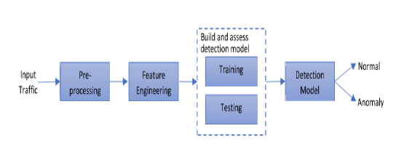

**SOFTWARE ENVIRONMENT**

Python is a general-purpose interpreted, interactive, object-oriented, and high-level programming language. An [interpreted language](https://en.wikipedia.org/wiki/Interpreted_language), Python has a design philosophy that emphasizes code [readability](https://en.wikipedia.org/wiki/Readability) (notably using [whitespace](https://en.wikipedia.org/wiki/Whitespace_character) indentation to delimit [code blocks](https://en.wikipedia.org/wiki/Code_block) rather than curly brackets or keywords), and a syntax that allows programmers to express concepts in fewer [lines of code](https://en.wikipedia.org/wiki/Source_lines_of_code) than might be used in languages such as [C++](https://en.wikipedia.org/wiki/C%2B%2B)or [Java](https://en.wikipedia.org/wiki/Java_(programming_language)). It provides constructs that enable clear programming on both small and large scales. Python interpreters are available for many [operating systems](https://en.wikipedia.org/wiki/Operating_system). [CPython](https://en.wikipedia.org/wiki/CPython), the [reference implementation](https://en.wikipedia.org/wiki/Reference_implementation) of Python, is [open source](https://en.wikipedia.org/wiki/Open_source) software and has a community-based development model, as do nearly all of its variant implementations. CPython is managed by the non-profit [Python Software Foundation](https://en.wikipedia.org/wiki/Python_Software_Foundation). Python features a [dynamic type](https://en.wikipedia.org/wiki/Dynamic_type) system and automatic [memory management](https://en.wikipedia.org/wiki/Memory_management). It supports multiple [programming paradigms](https://en.wikipedia.org/wiki/Programming_paradigm), including [object-oriented](https://en.wikipedia.org/wiki/Object-oriented_programming), [imperative](https://en.wikipedia.org/wiki/Imperative_programming), [functional](https://en.wikipedia.org/wiki/Functional_programming) and [procedural](https://en.wikipedia.org/wiki/Procedural_programming), and has a large and comprehensive [standard library](https://en.wikipedia.org/wiki/Standard_library)

## What is Python

## Python is a popular programming language. It was created by Guido van Rossum, and released in 1991.

**It is used for:**

* web development (server-side),
* software development,
* mathematics,
* system scripting.

**What can Python do**

* Python can be used on a server to create web applications.
* Python can be used alongside software to create workflows.
* Python can connect to database systems. It can also read and modify files.
* Python can be used to handle big data and perform complex mathematics.
* Python can be used for rapid prototyping, or for production-ready software development.

### Why Python

* Python works on different platforms (Windows, Mac, Linux, Raspberry Pi, etc).
* Python has a simple syntax similar to the English language.
* Python has syntax that allows developers to write programs with fewer lines than some other programming languages.
* Python runs on an interpreter system, meaning that code can be executed as soon as it is written. This means that prototyping can be very quick.
* Python can be treated in a procedural way, an object-orientated way or a functional way.

### Good to know

* The most recent major version of Python is Python 3, which we shall be using in this tutorial. However, Python 2, although not being updated with anything other than security updates, is still quite popular.
* In this tutorial Python will be written in a text editor. It is possible to write Python in an Integrated Development Environment, such as Thonny, Pycharm, Netbeans or Eclipse which are particularly useful when managing larger collections of Python files.

### Python Syntax compared to other programming languages

* Python was designed for readability, and has some similarities to the English language with influence from mathematics.
* Python uses new lines to complete a command, as opposed to other programming languages which often use semicolons or parentheses.
* Python relies on indentation, using whitespace, to define scope; such as the scope of loops, functions and classes. Other programming languages often use curly-brackets for this purpose.

**Python Install**

Many PCs and Macs will have python already installed.

To check if you have python installed on a Windows PC, search in the start bar for Python or run the following on the Command Line (cmd.exe):

C:\Users\Your Name>python --version

To check if you have python installed on a Linux or Mac, then on linux open the command line or on Mac open the Terminal and type:

python --version

If you find that you do not have python installed on your computer, then you can download it for free from the following website: https://www.python.org/

Python Quickstart

Python is an interpreted programming language, this means that as a developer you write Python (.py) files in a text editor and then put those files into the python interpreter to be executed.

The way to run a python file is like this on the command line:

C:\Users\Your Name>python helloworld.py

Where "helloworld.py" is the name of your python file.

Let's write our first Python file, called helloworld.py, which can be done in any text editor.

helloworld.py

print("Hello, World!")

Simple as that. Save your file. Open your command line, navigate to the directory where you saved your file, and run:

C:\Users\Your Name>python helloworld.py

The output should read:

Hello, World!

Congratulations, you have written and executed your first Python program.

The Python Command Line

To test a short amount of code in python sometimes it is quickest and easiest not to write the code in a file. This is made possible because Python can be run as a command line itself.

Type the following on the Windows, Mac or Linux command line:

C:\Users\Your Name>python

Or, if the "python" command did not work, you can try "py":

C:\Users\Your Name>py

From there you can write any python, including our hello world example from earlier in the tutorial:

C:\Users\Your Name>python

Python 3.6.4 (v3.6.4:d48eceb, Dec 19 2017, 06:04:45) [MSC v.1900 32 bit (Intel)] on win32

Type "help", "copyright", "credits" or "license" for more information.

>>>print("Hello, World!")

Which will write "Hello, World!" in the command line:

C:\Users\Your Name>python

Python 3.6.4 (v3.6.4:d48eceb, Dec 19 2017, 06:04:45) [MSC v.1900 32 bit (Intel)] on win32

Type "help", "copyright", "credits" or "license" for more information.

>>>print("Hello, World!")

Hello, World!

Whenever you are done in the python command line, you can simply type the following to quit the python command line interface:

exit()

**Virtual Environments and Packages**

**Introduction**

Python applications will often use packages and modules that don’t come as part of the standard library. Applications will sometimes need a specific version of a library, because the application may require that a particular bug has been fixed or the application may be written using an obsolete version of the library’s interface.

This means it may not be possible for one Python installation to meet the requirements of every application. If application A needs version 1.0 of a particular module but application B needs version 2.0, then the requirements are in conflict and installing either version 1.0 or 2.0 will leave one application unable to run.

The solution for this problem is to create a virtual environment, a self-contained directory tree that contains a Python installation for a particular version of Python, plus a number of additional packages.

Different applications can then use different virtual environments. To resolve the earlier example of conflicting requirements, application A can have its own virtual environment with version 1.0 installed while application B has another virtual environment with version 2.0. If application B requires a library be upgraded to version 3.0, this will not affect application A’s environment.

**Creating Virtual Environments**

The module used to create and manage virtual environments is called venv. venv will usually install the most recent version of Python that you have available. If you have multiple versions of Python on your system, you can select a specific Python version by running python3 or whichever version you want.

To create a virtual environment, decide upon a directory where you want to place it, and run the venv module as a script with the directory path:

python3 -m venv tutorial-env

This will create the tutorial-env directory if it doesn’t exist, and also create directories inside it containing a copy of the Python interpreter, the standard library, and various supporting files.

A common directory location for a virtual environment is .venv. This name keeps the directory typically hidden in your shell and thus out of the way while giving it a name that explains why the directory exists. It also prevents clashing with .env environment variable definition files that some tooling supports.

Once you’ve created a virtual environment, you may activate it.

On Windows, run:

tutorial-env\Scripts\activate.bat

On Unix or MacOS, run:

source tutorial-env/bin/activate

(This script is written for the bash shell. If you use the csh or fish shells, there are alternate activate.csh and activate.fish scripts you should use instead.)

Activating the virtual environment will change your shell’s prompt to show what virtual environment you’re using, and modify the environment so that running python will get you that particular version and installation of Python. For example:

$ source ~/envs/tutorial-env/bin/activate

(tutorial-env) $ python

Python 3.5.1 (default, May 6 2016, 10:59:36)

...

>>> import sys

>>>sys.path

['', '/usr/local/lib/python35.zip', ...,

'~/envs/tutorial-env/lib/python3.5/site-packages']

>>>

12.3. Managing Packages with pip

You can install, upgrade, and remove packages using a program called pip. By default pip will install packages from the Python Package Index, <https://pypi.org>. You can browse the Python Package Index by going to it in your web browser, or you can use pip’s limited search feature:

(tutorial-env) $ pip search astronomy

skyfield - Elegant astronomy for Python

gary - Galactic astronomy and gravitational dynamics.

novas - The United States Naval Observatory NOVAS astronomy library

astroobs - Provides astronomy ephemeris to plan telescope observations

PyAstronomy - A collection of astronomy related tools for Python.

...

pip has a number of subcommands: “search”, “install”, “uninstall”, “freeze”, etc. (Consult the Installing Python Modules guide for complete documentation for pip.)

You can install the latest version of a package by specifying a package’s name:

(tutorial-env) $ pip install novas

Collecting novas

Downloading novas-3.1.1.3.tar.gz (136kB)

Installing collected packages: novas

Running setup.py install for novas

Successfully installed novas-3.1.1.3

You can also install a specific version of a package by giving the package name followed by == and the version number:

(tutorial-env) $ pip install requests==2.6.0

Collecting requests==2.6.0

Using cached requests-2.6.0-py2.py3-none-any.whl

Installing collected packages: requests

Successfully installed requests-2.6.0

If you re-run this command, pip will notice that the requested version is already installed and do nothing. You can supply a different version number to get that version, or you can run pip install --upgrade to upgrade the package to the latest version:

(tutorial-env) $ pip install --upgrade requests

Collecting requests

Installing collected packages: requests

Found existing installation: requests 2.6.0

Uninstalling requests-2.6.0:

Successfully uninstalled requests-2.6.0

Successfully installed requests-2.7.0

pip uninstall followed by one or more package names will remove the packages from the virtual environment.

pip show will display information about a particular package:

(tutorial-env) $ pip show requests

Metadata-Version: 2.0

Name: requests

Version: 2.7.0

Summary: Python HTTP for Humans.

Home-page: http://python-requests.org

Author: Kenneth Reitz

Author-email: me@kennethreitz.com

License: Apache 2.0

Location: /Users/akuchling/envs/tutorial-env/lib/python3.4/site-packages

**Requires:**

pip list will display all of the packages installed in the virtual environment:

(tutorial-env) $ pip list

novas (3.1.1.3)

numpy (1.9.2)

pip (7.0.3)

requests (2.7.0)

setuptools (16.0)

pip freeze will produce a similar list of the installed packages, but the output uses the format that pip install expects. A common convention is to put this list in a requirements.txt file:

(tutorial-env) $ pip freeze > requirements.txt

(tutorial-env) $ cat requirements.txt

novas==3.1.1.3

numpy==1.9.2

requests==2.7.0

The requirements.txt can then be committed to version control and shipped as part of an application. Users can then install all the necessary packages with install -r:

(tutorial-env) $ pip install -r requirements.txt

Collecting novas==3.1.1.3 (from -r requirements.txt (line 1))

...

Collecting numpy==1.9.2 (from -r requirements.txt (line 2))

Collecting requests==2.7.0 (from -r requirements.txt (line 3))

Installing collected packages: novas, numpy, requests

Running setup.py install for novas

Successfully installed novas-3.1.1.3 numpy-1.9.2 requests-2.7.0

pip has many more options. Consult the Installing Python Modules guide for complete documentation for pip. When you’ve written a package and want to make it available on the Python Package Index, consult the Distributing Python Modules guide.

# ****Introduction to Artificial Intelligence****

Artificial Intelligence is an approach to make a computer, a robot, or a product to think how smart human think. AI is a study of how human brain think, learn, decide and work, when it tries to solve problems. And finally this study outputs intelligent software systems.The aim of AI is to improve computer functions which are related to human knowledge, for example, reasoning, learning, and problem-solving.

The intelligence is intangible. It is composed of

* Reasoning
* Learning
* Problem Solving
* Perception
* Linguistic Intelligence

The objectives of AI research are reasoning, knowledge representation, planning, learning, natural language processing, realization, and ability to move and manipulate objects. There are long-term goals in the general intelligence sector.

Approaches include statistical methods, computational intelligence, and traditional coding AI. During the AI research related to search and mathematical optimization, artificial neural networks and methods based on statistics, probability, and economics, we use many tools. Computer science attracts AI in the field of science, mathematics, psychology, linguistics, philosophy and so on.

# Trending AI Articles:

[1. Cheat Sheets for AI, Neural Networks, Machine Learning, Deep Learning & Big Data](https://becominghuman.ai/cheat-sheets-for-ai-neural-networks-machine-learning-deep-learning-big-data-678c51b4b463)

[2. Data Science Simplified Part 1: Principles and Process](https://becominghuman.ai/data-science-simplified-principles-and-process-b06304d63308)

[3. Getting Started with Building Realtime API Infrastructure](https://becominghuman.ai/getting-started-with-building-realtime-api-infrastructure-a19601fc794e)

[4. AI & NLP Workshop](https://becominghuman.ai/ai-nlp-workshop-7bc121986d61)

**Applications of AI**

· Gaming − AI plays important role for machine to think of large number of possible positions based on deep knowledge in strategic games. for example, chess,river crossing, N-queens problems and etc.

Natural Language Processing − Interact with the computer that understands natural language spoken by humans.

· Expert Systems − Machine or software provide explanation and advice to the users.

· Vision Systems − Systems understand, explain, and describe visual input on the computer.

· Speech Recognition − There are some AI based speech recognition systems have ability to hear and express as sentences and understand their meanings while a person talks to it. For example Siri and Google assistant.

· Handwriting Recognition − The handwriting recognition software reads the text written on paper and recognize the shapes of the letters and convert it into editable text.

· Intelligent Robots − Robots are able to perform the instructions given by a human.

**Major Goals**

* Knowledge reasoning
* Planning
* Machine Learning
* Natural Language Processing
* Computer Vision
* Robotics

# Machine Learning

### Introduction

Machine learning is a subfield of artificial intelligence (AI). The goal of machine learning generally is to understand the structure of data and fit that data into models that can be understood and utilized by people.

Although machine learning is a field within computer science, it differs from traditional computational approaches. In traditional computing, algorithms are sets of explicitly programmed instructions used by computers to calculate or problem solve. Machine learning algorithms instead allow for computers to train on data inputs and use statistical analysis in order to output values that fall within a specific range. Because of this, machine learning facilitates computers in building models from sample data in order to automate decision-making processes based on data inputs.

Any technology user today has benefitted from machine learning. Facial recognition technology allows social media platforms to help users tag and share photos of friends. Optical character recognition (OCR) technology converts images of text into movable type. Recommendation engines, powered by machine learning, suggest what movies or television shows to watch next based on user preferences. Self-driving cars that rely on machine learning to navigate may soon be available to consumers.

Machine learning is a continuously developing field. Because of this, there are some considerations to keep in mind as you work with machine learning methodologies, or analyze the impact of machine learning processes.

In this tutorial, we’ll look into the common machine learning methods of supervised and unsupervised learning, and common algorithmic approaches in machine learning, including the k-nearest neighbor algorithm, decision tree learning, and deep learning. We’ll explore which programming languages are most used in machine learning, providing you with some of the positive and negative attributes of each. Additionally, we’ll discuss biases that are perpetuated by machine learning algorithms, and consider what can be kept in mind to prevent these biases when building algorithms.

## Machine Learning Methods

In machine learning, tasks are generally classified into broad categories. These categories are based on how learning is received or how feedback on the learning is given to the system developed.

Two of the most widely adopted machine learning methods are **supervised learning** which trains algorithms based on example input and output data that is labeled by humans, and **unsupervised learning** which provides the algorithm with no labeled data in order to allow it to find structure within its input data. Let’s explore these methods in more detail.

### Supervised Learning

In supervised learning, the computer is provided with example inputs that are labeled with their desired outputs. The purpose of this method is for the algorithm to be able to “learn” by comparing its actual output with the “taught” outputs to find errors, and modify the model accordingly. Supervised learning therefore uses patterns to predict label values on additional unlabeled data.

For example, with supervised learning, an algorithm may be fed data with images of sharks labeled as fish and images of oceans labeled as water. By being trained on this data, the supervised learning algorithm should be able to later identify unlabeled shark images as fish and unlabeled ocean images as water.

A common use case of supervised learning is to use historical data to predict statistically likely future events. It may use historical stock market information to anticipate upcoming fluctuations, or be employed to filter out spam emails. In supervised learning, tagged photos of dogs can be used as input data to classify untagged photos of dogs.

### Unsupervised Learning

In unsupervised learning, data is unlabeled, so the learning algorithm is left to find commonalities among its input data. As unlabeled data are more abundant than labeled data, machine learning methods that facilitate unsupervised learning are particularly valuable.

The goal of unsupervised learning may be as straightforward as discovering hidden patterns within a dataset, but it may also have a goal of feature learning, which allows the computational machine to automatically discover the representations that are needed to classify raw data.

Unsupervised learning is commonly used for transactional data. You may have a large dataset of customers and their purchases, but as a human you will likely not be able to make sense of what similar attributes can be drawn from customer profiles and their types of purchases. With this data fed into an unsupervised learning algorithm, it may be determined that women of a certain age range who buy unscented soaps are likely to be pregnant, and therefore a marketing campaign related to pregnancy and baby products can be targeted to this audience in order to increase their number of purchases.

Without being told a “correct” answer, unsupervised learning methods can look at complex data that is more expansive and seemingly unrelated in order to organize it in potentially meaningful ways. Unsupervised learning is often used for anomaly detection including for fraudulent credit card purchases, and recommender systems that recommend what products to buy next.

In unsupervised learning, untagged photos of dogs can be used as input data for the algorithm to find likenesses and classify dog photos together.

## Approaches

As a field, machine learning is closely related to computational statistics, so having a background knowledge in statistics is useful for understanding and leveraging machine learning algorithms.

For those who may not have studied statistics, it can be helpful to first define correlation and regression, as they are commonly used techniques for investigating the relationship among quantitative variables. **Correlation** is a measure of association between two variables that are not designated as either dependent or independent. **Regression** at a basic level is used to examine the relationship between one dependent and one independent variable. Because regression statistics can be used to anticipate the dependent variable when the independent variable is known, regression enables prediction capabilities.

Approaches to machine learning are continuously being developed. For our purposes, we’ll go through a few of the popular approaches that are being used in machine learning at the time of writing.

### k-nearest neighbor

The k-nearest neighbor algorithm is a pattern recognition model that can be used for classification as well as regression. Often abbreviated as k-NN, the **k** in k-nearest neighbor is a positive integer, which is typically small. In either classification or regression, the input will consist of the k closest training examples within a space.

We will focus on k-NN classification. In this method, the output is class membership. This will assign a new object to the class most common among its k nearest neighbors. In the case of k = 1, the object is assigned to the class of the single nearest neighbor.

Let’s look at an example of k-nearest neighbor. In the diagram below, there are blue diamond objects and orange star objects. These belong to two separate classes: the diamond class and the star class.

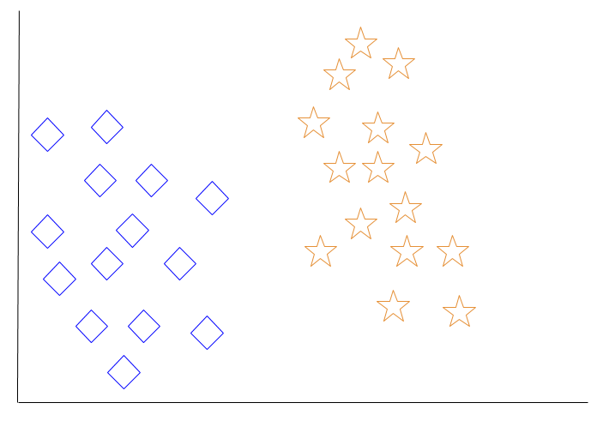

When a new object is added to the space — in this case a green heart — we will want the machine learning algorithm to classify the heart to a certain class.

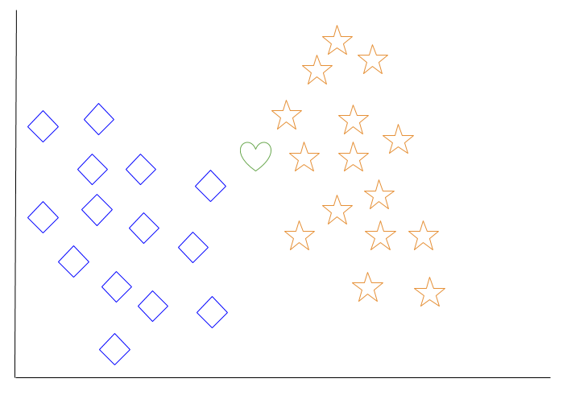

When we choose k = 3, the algorithm will find the three nearest neighbors of the green heart in order to classify it to either the diamond class or the star class.

In our diagram, the three nearest neighbors of the green heart are one diamond and two stars. Therefore, the algorithm will classify the heart with the star class.

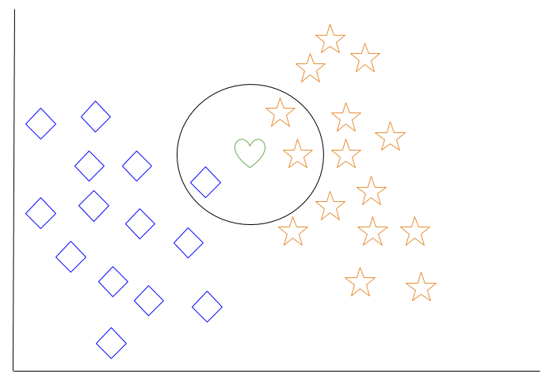

Among the most basic of machine learning algorithms, k-nearest neighbor is considered to be a type of “lazy learning” as generalization beyond the training data does not occur until a query is made to the system.

### Decision Tree Learning

For general use, decision trees are employed to visually represent decisions and show or inform decision making. When working with machine learning and data mining, decision trees are used as a predictive model. These models map observations about data to conclusions about the data’s target value.

The goal of decision tree learning is to create a model that will predict the value of a target based on input variables.

In the predictive model, the data’s attributes that are determined through observation are represented by the branches, while the conclusions about the data’s target value are represented in the leaves.

When “learning” a tree, the source data is divided into subsets based on an attribute value test, which is repeated on each of the derived subsets recursively. Once the subset at a node has the equivalent value as its target value has, the recursion process will be complete.

Let’s look at an example of various conditions that can determine whether or not someone should go fishing. This includes weather conditions as well as barometric pressure conditions.

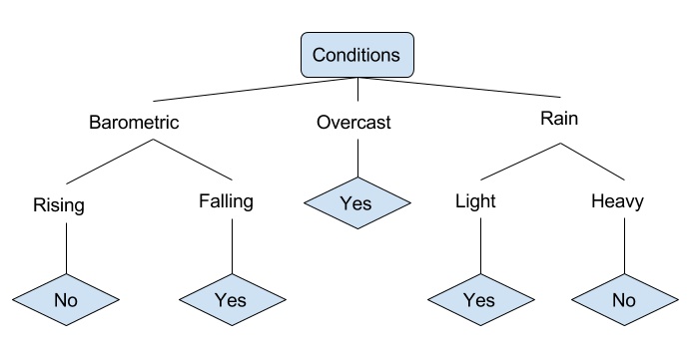

In the simplified decision tree above, an example is classified by sorting it through the tree to the appropriate leaf node. This then returns the classification associated with the particular leaf, which in this case is either a Yes or a No. The tree classifies a day’s conditions based on whether or not it is suitable for going fishing.

A true classification tree data set would have a lot more features than what is outlined above, but relationships should be straightforward to determine. When working with decision tree learning, several determinations need to be made, including what features to choose, what conditions to use for splitting, and understanding when the decision tree has reached a clear ending.

# Introduction to Deep Learning

What is deep learning

Deep learning is a branch of [machine learning](https://www.geeksforgeeks.org/introduction-machine-learning/) which is completely based on [artificial neural networks](https://www.geeksforgeeks.org/tag/neural-network/), as neural network is going to mimic the human brain so deep learning is also a kind of mimic of human brain. In deep learning, we don’t need to explicitly program everything. The concept of deep learning is not new. It has been around for a couple of years now. It’s on hype nowadays because earlier we did not have that much processing power and a lot of data. As in the last 20 years, the processing power increases exponentially, deep learning and machine learning came in the picture.  
A formal definition of deep learning is- neurons

Deep learning is a particular kind of machine learning that achieves great power and flexibility by learning to represent the world as a nested hierarchy of concepts, with each concept defined in relation to simpler concepts, and more abstract representations computed in terms of less abstract ones.

In human brain approximately 100 billion neurons all together this is a picture of an individual neuron and each neuron is connected through thousand of their neighbours.  
The question here is how do we recreate these neurons in a computer. So, we create an artificial structure called an artificial neural net where we have nodes or neurons. We have some neurons for input value and some for output value and in between, there may be lots of neurons interconnected in the hidden layer.

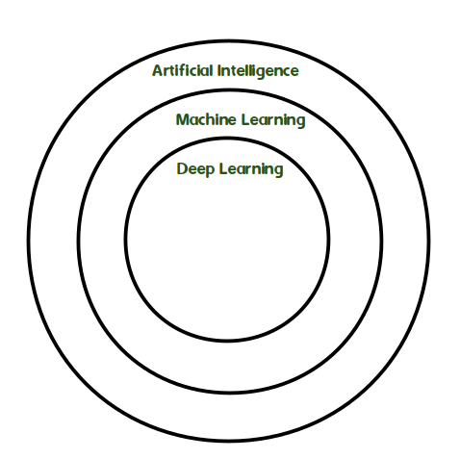

**MODULES**

1. **Data Collection:**

Collect sufficient data samples and legitimate software samples.

2. **Data Preprocessing:**

Data Augmented techniques will be used for better performance

3. **Train and Test Modeling:**

Split the data into train and test data Train will be used for trainging the model and Test data to check the performance.

4. **Attack Detection Model:**

Based on the model trained algorithm will detect whether the given transaction is anomalous or not.

**Method :**

Important steps of the algorithm are given in below and described in the Fig.1 1) Normalization of every dataset. 2) Convert that dataset into the testing and training. 3) Form IDS models with the help of using RF, ANN, CNN and SVM algorithms. 4) Evaluate every model’s performances

**Advantages :**

Advantages of the proposed systems are follows:

▪ Protection from malicious attacks on your network.

▪ Deletion and/or guaranteeing malicious elements within a preexisting network.

▪ Prevents users from unauthorized access to the network.

▪ Deny's programs from certain resources that could be infected.

▪ Securing confidential information

**Algorithms used:**

**Artifiical Neural Network (ANN).** The plan thought of an ANN is to mirror the manner in which human cerebrums work. An ANN contains an info layer, a few secret layers and a yield layer. The units in neighboring layers are completely associated. An ANN contains a colossal number of units and can hypothetically estimated subjective capacities; subsequently, it has solid fitting capacity, particularly for nonlinear capacities. Because of the perplexing model design, preparing ANNs is tedious.

**Support Vector Machine (SVM).** The system in SVMs is to discover a maximum edge partition hyperplane in the n-measurement highlight space. SVMs can accomplish satisfying outcomes even with limited scope preparing sets in light of the fact that the partition hyperplane is resolved simply by few help vectors. In any case, SVMs are delicate to commotion close the hyperplane.

**K-Nearest Neighbor (KNN).** The center thought of KNN depends on the complex theory. On the off chance that the majority of an example's neighbors have a place with a similar class, the example has a high likelihood of having a place with the class. In this manner, the grouping result is simply identified with the top-k closest neighbors. The boundary k enormously impacts the presentation of KNN models. The more modest k is, the more intricate the model is and the higher the danger of overfitting. On the other hand, the bigger k is, the easier the model is and the more fragile the fitting capacity.

**Naive Bayes**. The Naïve Bayes calculation depends on the restrictive likelihood and the speculation of property autonomy. For each example, the Naïve Bayes classifier computes the contingent probabilities for various classes.

**Decision tree**. The choice tree calculation characterizes information utilizing a progression of rules. The model is tree like, which makes it interpretable. The choice tree calculation can consequently prohibit immaterial and repetitive highlights. The learning interaction incorporates include choice, tree age, and tree pruning. When preparing a choice tree model, the calculation chooses the most appropriate highlights independently and produces kid hubs from the root hub. The choice tree is an essential classifier. Some high level calculations, for example, the arbitrary woodland and the limit slope boosting (XGBoost), comprise of various choice trees.

**Clustering.** Clustering depends on closeness hypothesis, i.e., gathering exceptionally comparative information into similar bunches and gathering less-comparative information into various groups. Unique in relation to order, bunching is a kind of unaided learning. No earlier information or named information is required for bunching calculations; along these lines, the informational collection necessities are moderately low. Be that as it may, when utilizing bunching calculations to identify assaults, it is important to allude outer data.

### SYSTEM TESTING

The purpose of testing is to discover errors. Testing is the process of trying to discover every conceivable fault or weakness in a work product. It provides a way to check the functionality of components, sub assemblies, assemblies and/or a finished product It is the process of exercising software with the intent of ensuring that the Software system meets its requirements and user expectations and does not fail in an unacceptable manner. There are various types of test. Each test type addresses a specific testing requirement.

**TYPES OF TESTS:**

**Unit testing**

Unit testing involves the design of test cases that validate that the internal program logic is functioning properly, and that program inputs produce valid outputs. All decision branches and internal code flow should be validated. It is the testing of individual software units of the application .it is done after the completion of an individual unit before integration. This is a structural testing, that relies on knowledge of its construction and is invasive. Unit tests perform basic tests at component level and test a specific business process, application, and/or system configuration. Unit tests ensure that each unique path of a business process performs accurately to the documented specifications and contains clearly defined inputs and expected results.

**Integration testing**

Integration tests are designed to test integrated software components to determine if they actually run as one program. Testing is event driven and is more concerned with the basic outcome of screens or fields. Integration tests demonstrate that although the components were individually satisfaction, as shown by successfully unit testing, the combination of components is correct and consistent. Integration testing is specifically aimed at exposing the problems that arise from the combination of components.

**Functional test**

Functional tests provide systematic demonstrations that functions tested are available as specified by the business and technical requirements, system documentation, and user manuals.

Functional testing is centered on the following items:

Valid Input : identified classes of valid input must be accepted.

Invalid Input : identified classes of invalid input must be rejected.

Functions : identified functions must be exercised.

Output : identified classes of application outputs must be exercised.

Systems/Procedures: interfacing systems or procedures must be invoked.

Organization and preparation of functional tests is focused on requirements, key functions, or special test cases. In addition, systematic coverage pertaining to identify Business process flows; data fields, predefined processes, and successive processes must be considered for testing. Before functional testing is complete, additional tests are identified and the effective value of current tests is determined.

**System Test**

System testing ensures that the entire integrated software system meets requirements. It tests a configuration to ensure known and predictable results. An example of system testing is the configuration oriented system integration test. System testing is based on process descriptions and flows, emphasizing pre-driven process links and integration points.

**White Box Testing**

White Box Testing is a testing in which in which the software tester has knowledge of the inner workings, structure and language of the software, or at least its purpose. It is purpose. It is used to test areas that cannot be reached from a black box level.

**Black Box Testing**

Black Box Testing is testing the software without any knowledge of the inner workings, structure or language of the module being tested. Black box tests, as most other kinds of tests, must be written from a definitive source document, such as specification or requirements document, such as specification or requirements document. It is a testing in which the software under test is treated, as a black box .you cannot “see” into it. The test provides inputs and responds to outputs without considering how the software works.

**Unit Testing:**

Unit testing is usually conducted as part of a combined code and unit test phase of the software lifecycle, although it is not uncommon for coding and unit testing to be conducted as two distinct phases.

**Test strategy and approach**

Field testing will be performed manually and functional tests will be written in detail.

**Test objectives**

* All field entries must work properly.
* Pages must be activated from the identified link.
* The entry screen, messages and responses must not be delayed.

**Features to be tested**

* Verify that the entries are of the correct format
* No duplicate entries should be allowed
* All links should take the user to the correct page.

# Integration Testing

Software integration testing is the incremental integration testing of two or more integrated software components on a single platform to produce failures caused by interface defects.

The task of the integration test is to check that components or software applications, e.g. components in a software system or – one step up – software applications at the company level – interact without error.

**Test Results:** All the test cases mentioned above passed successfully. No defects encountered.

**Acceptance Testing**

User Acceptance Testing is a critical phase of any project and requires significant participation by the end user. It also ensures that the system meets the functional requirements.

**Test Results:** All the test cases mentioned above passed successfully. No defects encountered.

**SCREENS**

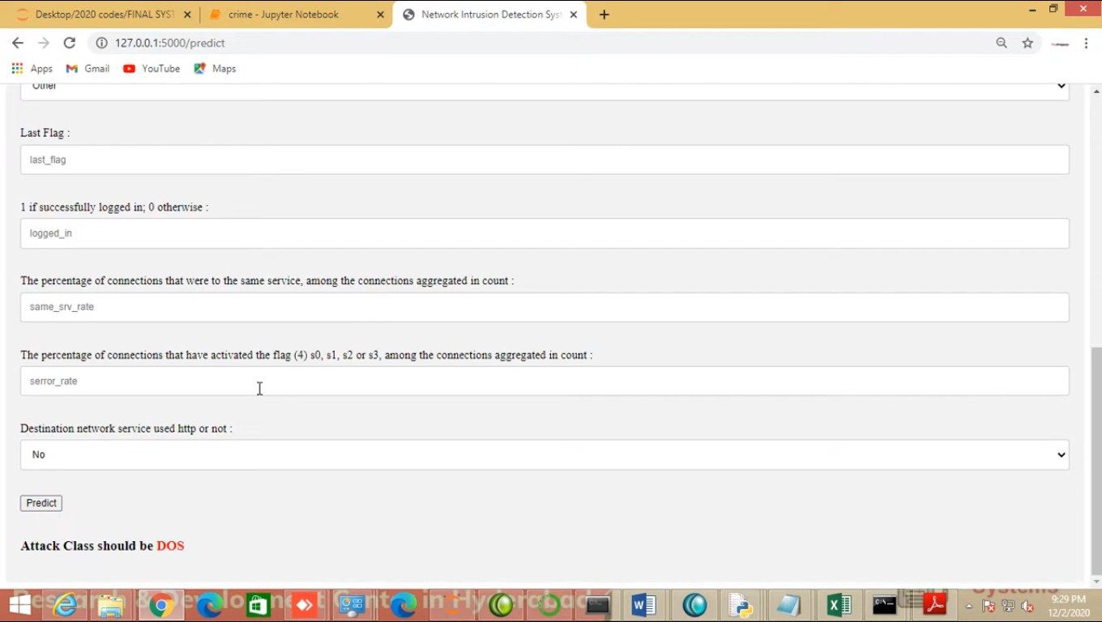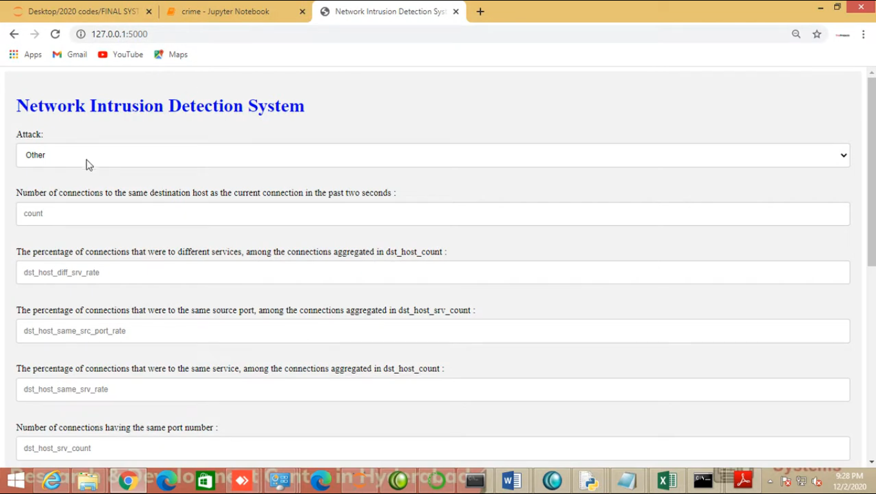

**CONCLUSION:**

At the present time, assessments of help vector machine, ANN, CNN, Random Forest and significant learning estimations reliant upon current CICIDS2017 dataset were presented moderately. Results show that the significant learning estimation performed generally best results over SVM, ANN, RF and CNN. We will use port scope attempts just as other attack types with AI and significant learning computations, apache Hadoop and shimmer advancements together ward on this dataset later on. Every one of these estimation assists us with recognizing the digital assault in network. It occurs in the manner that when we think about long back a long time there might be such countless assaults occurred so when these assaults are perceived then the highlights at which esteems these assaults are going on will be put away in some datasets. So by utilizing these datasets we will anticipate if digital assault is finished. These forecasts should be possible by four calculations like SVM, ANN, RF, CNN this paper assists with distinguishing which calculation predicts the best precision rates which assists with foreseeing best outcomes to recognize the digital assaults occurred or not.

**REFERENCES**

[1] K. Graves, Ceh: Official certified ethical hacker review guide: Exam 312-50. John Wiley & Sons, 2007.

[2] R. Christopher, “Port scanning techniques and the defense against them,” SANS Institute, 2001.

[3] M. Baykara, R. Das¸, and I. Karado ˘gan, “Bilgi g ¨uvenli ˘gi sistemlerinde kullanilan arac¸larin incelenmesi,” in 1st International Symposium on Digital Forensics and Security (ISDFS13), 2013, pp. 231–239.

[4] Rashmi T V. “Predicting the System Failures Using Machine Learning Algorithms”. International Journal of Advanced Scientific Innovation, vol. 1, no. 1, Dec. 2020, doi:10.5281/zenodo.4641686.

[5] S. Robertson, E. V. Siegel, M. Miller, and S. J. Stolfo, “Surveillance detection in high bandwidth environments,” in DARPA Information Survivability Conference and Exposition, 2003. Proceedings, vol. 1. IEEE, 2003, pp. 130–138.

[6] K. Ibrahimi and M. Ouaddane, “Management of intrusion detection systems based-kdd99: Analysis with lda and pca,” in Wireless Networks and Mobile Communications (WINCOM), 2017 International Conference on. IEEE, 2017, pp. 1–6.

[7] Girish L, Rao SKN (2020) “Quantifying sensitivity and performance degradation of virtual machines using machine learning.”, Journal of Computational and Theoretical Nanoscience, Volume 17, Numbers 9-10, September/October 2020, pp. 4055-4060(6) https://doi.org/10.1166/jctn.2020.9019

[8] L. Sun, T. Anthony, H. Z. Xia, J. Chen, X. Huang, and Y. Zhang, “Detection and classification of malicious patterns in network traffic using benford’s law,” in Asia-Pacific Signal and Information Processing Association Annual Summit and Conference (APSIPA ASC), 2017. IEEE, 2017, pp. 864–872.

[9] S. M. Almansob and S. S. Lomte, “Addressing challenges for intrusion detection system using naive bayes and pca algorithm,” in Convergence in Technology (I2CT), 2017 2nd International Conference for. IEEE, 2017, pp. 565–568.

[10] M. C. Raja and M. M. A. Rabbani, “Combined analysis of support vector machine and principle component analysis for ids,” in IEEE International Conference on Communication and Electronics Systems, 2016, pp. 1–5.

[11] Nayana, Y., Justin Gopinath, and L. Girish. "DDoS Mitigation using Software Defined Network." International Journal of Engineering Trends and Technology (IJETT) 24.5 (2015): 258-264.

[12] Shambulingappa H S. “Crude Oil Price Forecasting Using Machine Learning”. International Journal of Advanced Scientific Innovation, vol. 1, no. 1, Mar. 2021, doi:10.5281/zenodo.4641697.

[13] D. Aksu, S. Ustebay, M. A. Aydin, and T. Atmaca, “Intrusion detection with comparative analysis of supervised learning techniques and fisher score feature selection algorithm,” in International Symposium on Computer and Information Sciences. Springer, 2018, pp. 141– 149.